Satellite-derived NDVI predicts forage availability in a wild ungulate system: validation using field-collected vegetation biomass on a temperate grassland

Shane Butt1, Kirsty Macphie1, Richard S. Turner1, Sean J. Morris1, Alison Morris1, Robin Pakeman2, Loeske E. B. Kruuk1, J.M. Pemberton1 & H. Froy1

1. Institute of Ecology and Evolution

School of Biological Sciences

University of Edinburgh

1. James Hutton Institute

Aberdeen

Keywords: Landsat; MODIS; satellite; NDVI; EVI; phenology; vegetation; grazing; red deer *Cervus elaphus*

# **Abstract**

Satellite-derived vegetation indices (VIs) provide a powerful means to quantify habitat variation in long-term ecological studies, but their reliability as proxies for forage availability in wild herbivore populations remains underexplored. We used three decades of Landsat satellite imagery (1991–2023) to generate a 30m resolution dataset of a proxy measure for annual vegetation greenness – the Normalized Difference Vegetation Index (NDVI) – for the Isle of Rum, Scotland, home to a long-term study of wild red deer (Cervus elaphus). We validated the NDVI data against field-collected vegetation biomass data and compared it with a coarser-resolution (500m) MODIS Enhanced Vegetation Index (EVI) metric. Landsat NDVI was positively correlated with both biomass and EVI, supporting its ecological relevance as a measure of forage availability. All three metrics have increased over the last three decades, indicating a long-term greening trend, with the higher resolution Landsat dataset revealing a variation in the rate of change among vegetation types, including grassland habitats preferred by deer. These findings suggest an increase in foraging availability over time and offer a possible mechanism underpinning observed demographic shifts, such as earlier calving. Our approach provides a transferable framework for integrating satellite data with individual-based field studies, demonstrating how remote sensing can enhance ecological inference in long-term wildlife research.

# **Introduction**

Satellite remote sensing, particularly the use of vegetation indices (VIs) such as the Normalised Difference Vegetation Index (NDVI), has become an increasingly valuable tool for assessing environmental variation in ecological studies of animal populations (Kerr & Ostrovsky, 2003; Pettorelli et al., 2005; Cole et al., 2015).NDVI, the most widely used vegetation index in ecological studies (Manson et al., 2015; Bahrami et al., 2022), serves as a proxy for vegetation health, productivity and coverage (Pettorelli et al., 2011), and in some cases, has been linked to foraging conditions, phenology and demographic variation in herbivores (Pettorelli et al., 2006; Hamel et al., 2009; Hurley et al., 2014; Fauchald et al., 2017). However, its effectiveness as a direct measure of food availability remains uncertain (Johnson et al., 2018), as NDVI does not distinguish between preferred and unpreferred vegetation, nor does it convey direct information about vegetation quality or quantity. The utility of NDVI as an ecological indicator can also vary depending on habitat type, vegetation structure, and local environmental conditions, making interpretation more complex (Pettorelli et al., 2005; Piedallu et al., 2019). While many studies rely solely on satellite-derived indices, few can ground-truth these data against field-based vegetation measures, limiting their ecological interpretability. Furthermore, ecologists must be aware of the potential hazards that need to be overcome to robustly utilise remote sensing data from different satellites (reviewed in Pettorelli et al., 2011).

Many ecological and evolutionary processes unfold over long timescales, making long-term datasets essential for detecting meaningful trends (Perrins, 1965; Grant & Grant, 2002; Pucek et al., 2004; Clutton-Brock & Pemberton, 2004; Clutton-Brock & Sheldon, 2010; Ripple & Beschta, 2012). A key advantage of long-term population studies is the acquisition of knowledge about the species or study system in focus, which can only come from decades of observation. This lends long-term population study systems significant rigour, making them valuable resources to test fundamental scientific hypotheses in wild populations (Reinke et al., 2019). The Isle of Rum red deer (*Cervus elaphus*) study is a prime example of this: ongoing since 1971, it has been at the forefront of pioneering research in a range of questions across ecology and evolution in wild mammals (Pemberton et al., 2022). For most of the study, samples from a vegetation community selectively grazed by deer have been collected alongside long-term phenotypic, genetic and life-history data. The study therefore offers a rare opportunity to ground-truth remote sensing vegetation index data, supporting the use of NDVI as a proxy for food availability in wild herbivore studies.

Long-term population studies are uniquely suited to investigating how environmental variation shapes ecological and evolutionary processes, particularly as climate change drives shifts in vegetation and habitat conditions over years and decades (Pacifici et al., 2015; Parmesan, 2006; Garant, 2020). However, while individual-based data on focal species are often rich, comparable environmental data are typically limited in spatial resolution or ecological relevance, especially when based only on local weather stations. This makes it difficult to assess the spatial and temporal dimensions of environmental change and their effects on population dynamics.

Vegetation is a key pathway through which climate change influences ecosystems, with impacts on plant growth rates, quality, quantity, and seasonality (Thornton et al., 2014). For herbivores, whose populations depend directly on forage availability, capturing both the timing and spatial heterogeneity of vegetation change is crucial to understanding its impact. Satellite remote sensing provides a powerful tool for this, enabling consistent monitoring of vegetation over space and time (Pettorelli et al., 2005; Hamel et al., 2009; Santin-Janin et al., 2009), with indices like NDVI offering a valuable complement to ground-collected data in long-term population studies.

Previous studies of the red deer population on the Isle of Rum have revealed temporal and spatial variation in multiple traits, including lifetime breeding success (Rose et al., 1998), parturition dates (Bonnet et al., 2019), vital rates (Coulson et al., 2004) and parasite load (Albery et al., 2018). However, the contribution of vegetation to these changes is unknown. To enable future analyses of the association between spatiotemporal variation in vegetation and red deer performance, we constructed a high spatial resolution NDVI dataset from remote sensing data, covering the years 1991 – 2023. To do this, we used data from the Landsat satellite program which has been operational since 1972, with vegetation indices (VIs) available since Landsat 4 launched in 1985. These satellites capture images at a spatial resolution of 30m, allowing us to quantify spatial variation in “greenness”, and to compare the temporal trends in the different vegetation types which make up the study area (Figure 1). However, each Landsat satellite captures an image only every sixteen days, which limits data volume, especially considering the study site experiences frequent cloud cover. Specifically, we used data from the Landsat 5, Landsat 7 and Landsat 8 satellites. To validate the temporal variation in NDVI in the Landsat dataset, we used monthly measures of vegetation biomass collected since 1987 as part of the red deer study. We also utilised the Moderate Resolution Imaging Spectroradiometer (MODIS) satellite program, which provides daily images covering the Rum study area at 500m spatial resolution from 2000 – present. This relatively coarse spatial resolution provides limited information on the potentially variable vegetation dynamics across the study site, and the shorter duration cuts off a significant portion of the deer study. However, the data are considered high quality and consistent, with a single sensor in place since launch in December 1999 (Gao et al., 2003; Jarchow et al., 2018), offering further validation of the Landsat dataset. To capture this data, we used the MCD12Q2 product provided by the United States Geographical Survey (Friedl et al., 2022), which outputs the Enhanced Vegetation Index – this is a similar metric to NDVI and has been shown to be strongly correlated (Gao et al., 2000; Huete et al., 2002; Vermote et al., 2016; Alademomi et al., 2020).

The objectives of this study are therefore threefold: (1) to evaluate the utility of the Landsat dataset by validating against field-measured vegetation biomass data from grassland selectively grazed by red deer, which serves as ground truth; (2) to assess the reliability of the Landsat dataset by comparing with MODIS, in terms of both temporal and spatial variation; and (3) to investigate temporal trends in vegetation on Rum using the field-measured biomass data, MODIS and Landsat datasets, providing insights into potential ecological changes over time and across the landscape.

# **Methods**

**Study area**

Rum (57°N, 6°20’W) has a wet, mild oceanic climate. The moorland vegetation is dominated by blanket bog and wet heath interspersed with grassland on better drained areas. The North Block study area (Figure 1) covers ~12.7km2 divided into different vegetation types using a map from the NatureScot Spatial Data Hub ([*https://opendata.nature.scot/datasets/snh::nvc-habitat-polygons/explore?location=57.683190%2C-4.979327%2C6.86*](https://opendata.nature.scot/datasets/snh::nvc-habitat-polygons/explore?location=57.683190%2C-4.979327%2C6.86)), originally commissioned in 1975 and published in 2023. The polygons were mapped using the National Vegetation Classifications with polygons identified at the subcommunity level (55 subcommunities). To reduce the complexity of the classification we aggregated these subcommunities into eight main vegetation types: acid grass, blanket bog, calcareous grass, dry heath, maritime cliff, poor dry grass, wet grass, and wet heath (Figure 1; Table S1; Figure S1). Small portions of the study area remain unclassified because they are not vegetated. The predominant vegetation types in the study area are wet heath and blanket bog, along with smaller patches of dry (and herb-rich) heaths, acid grassland, wet grass and calcareous grassland (Moore et al., 2015). The latter three of these are favoured by the deer for grazing (Gordon, 1989).

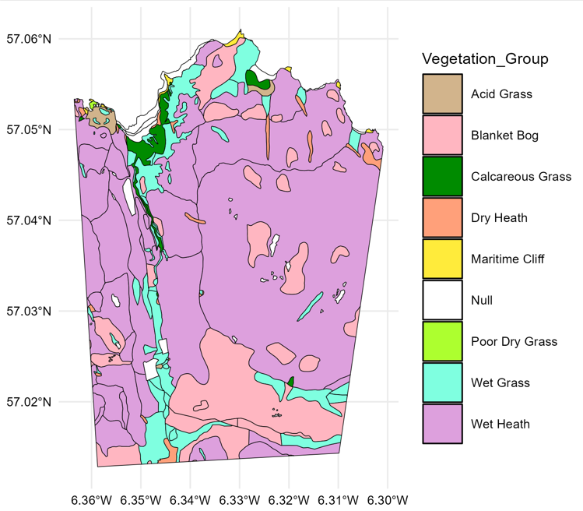**Figure 1:** Vegetation map of the Isle of Rum North Block study area, from the NatureScot Spatial Data Hub. The calcareous grass sand wet grass areas in the Kilmory Bay area and running down Kilmory Glen, and the acid grass Laundry Greens to the northwest of Kilmory Bay, are preferred by the deer for grazing.

**Long-term vegetation monitoring on Rum**

Vegetation data were collected across the study area at six plots on the calcareous herb-rich Agrostis/Festuca grasslands favoured by the deer (Figure 1), consistently from 1987-2023. At each plot, two vegetation cages (0.5 m x 0.5 m) were used to exclude grazing. Five 10 cm x 10 cm quadrats were picked to soil/root level from inside and outside each cage at each plot, monthly between March and November inclusive. Approximately 20% subsamples were sorted into *live grass & herbs*, *dead gras & herbs*, *moss* and *heather* and then over-dried at 60°C alongside the remaining 80% unsorted. Three metrics were estimated each month at each plot. *Standing Crop* is the dried weight of live material outside the cages. *Productivity* is estimated by subtracting the live dried weight inside a cage in each month with the live dried weight outside the cage in the preceding month (hence is not available for March when picking begins). *Offtake* is estimated by comparing the live dried weight inside the cages from the live dried weight outside the cages in the same month. Live standing crop data were used for comparison to the satellite data as the live grazed vegetation outside the cages represents the majority of calcareous grassland ground cover observed by the satellites.

The temporal pattern in standing crop within each year (Figure S2) shows the annual peak in biomass occurred in June or July, so the annual mean standing crop across June and July for all cage plots was used as an estimate of the maximum standing crop reached. This is the most comparable metric to the NDVIMax (peak vegetation greenness) estimates produced from the Landsat data (see below).

**Satellite-derived vegetation Indices: NDVI and EVI**

NDVI is calculated using the reflectance values of near-infrared (NIR) and red-light wavelengths (Pettorelli, 2013; Huang et al., 2021). The formula for NDVI is

NDVI = $\frac{\left(NIR - Red\right)}{\left(NIR+Red\right)},$ (1)

resulting in a value between -1 and 1. Chlorophyll, the green pigment in plant cells, strongly absorbs light in the red region of the spectrum and reflects light in the near-infrared (NIR) region. Healthy and actively growing vegetation with high chlorophyll content will exhibit higher reflectance in the NIR and lower reflectance in the red, resulting in a higher NDVI value. Low or negative values suggest non-vegetated surfaces, such as water, rocks, roads or buildings.

EVI also commands attention in many ecology studies, particularly in areas of dense vegetation and rainforest as it has greater sensitivity in high biomass regions. Like NDVI, EVI ranges from -1 to 1, but it does not depend on chlorophyll content. Instead, it responds to variations in canopy structure and type (Zou & Mõttus, 2017)**.** It uses the blue light band in its calculation, which allows correction for aerosol influences present in the red band (Huete et al., 2002). The formula for EVI is

EVI = $G\frac{\left(NIR - Red\right)}{\left(NIR+C_{1}Red-C_{2}Blue+L\right)},$ (2)

where G is the gain factor; L is the canopy background adjustment to account for nonlinear, differential NIR and red-light transfer through the canopy; and C1​ and C2​ are the coefficients for the aerosol resistance term. The coefficients used in the EVI algorithm are L = 1, C1 = 6, C2 = 7.5 and G = 2.5 (Huete et al., 1994).

**Landsat data**

We used data from Landsat 5, Landsat 7 and Landsat 8 in our study; Landsat 4 and Landsat 9 were available, but Landsat 4 data are sparse and yielded only two clear images, while Landsat 9 was only launched in 2021. Landsat offers the benefit of relatively high spatial resolution (30m x 30m) but has a relatively low temporal resolution (16 days) for each satellite. However, because the three Landsat satellites we collect data from pass over our study area at different times in their respective orbits, an image is available on average every nine days across the period; this number is positively skewed towards recent years, when two or three satellites are in orbit concurrently. Our raw dataset ranged between March 1984 and December 2023, though the availability and frequency of images varied due to changes in satellite missions. Due to Rum’s high latitude and the timing of Landsat satellite overpasses, images are only available from March to October each year. From 1984 to 2012, data were primarily collected from Landsat 5, with additional coverage from Landsat 7 after 1999. However, the failure of Landsat 7’s scan line corrector in 2003 introduced significant data gaps (~22% per scene; Storey et al., 2005). The launch of Landsat 8 in 2013 improved data availability, with images captured approximately every eight days when combined with Landsat 7. Due to low data availability, we excluded the years 1984-1990, 2004 and 2012 from our analyses.

***Data processing: LandsatTS***

We used the *LandsatTS* *(v1.2.3)* R package (Berneret al., 2023) to download and process Google Earth Engine-hosted Level-2 Collection-2 Tier-1 Landsat 5 (Thematic Mapper [TM]), Landsat 7 (Enhanced Thematic Mapper Plus [ETM+]), and Landsat 8 (Operational Land Imager and Thermal Infra-Red Scanner [OLI-TIRS]) satellite imagery. We bounded the geographical data range using a vegetation categorised shapefile of the Isle of Rum North Block study area. Each image was pre-processed to categorise each pixel using the automated function mask (*cfmask*) algorithm (Zhu & Woodcock 2012). Pixels were categorised as either cloud, cloud shadow, snow, water, or valid. Surface reflectance measurements with geometric uncertainty above 30m were excluded, as were measurements where the solar zenith angle was abnormally high (above 60m). Measurements with impossibly high (> 1) and abnormally low (< 0.005) reflectance were also excluded; the lower limit allowed us to avoid pixels containing only a small fraction of vegetation, whereas the upper limit was set to avoid potential biases from a saturation effect that can occur in very dense vegetation areas (Mutanga et al., 2023). Images for which > 95% of the pixels were invalid for any reason were discarded entirely as a conservative precaution. These pre-processing filters reduced the size of the dataset by 87%, from 27.5 million datapoints to 3.6 million; almost all (97%) of the reduction was due to filtering out cloud covered pixels. Each pixel was assigned to a vegetation type based on the vegetation map in Figure 1, determined by the location of the pixel centroid. Specific vegetation types that lacked sufficient representation (poor dry grass, maritime cliff) and pixels assigned to unmapped areas were removed. Pixels containing NDVI values < 0.15 were removed, as values below this threshold typically indicate non-biomass areas such as rocks, beach, concrete or buildings (Eastman et al., 2013).

***Cross Calibration between Landsat 5, 7 and 8***

We used the *LandsatTS* package to cross calibrate the surface reflectance measurements between the three satellites (Figure S3). The cross-calibration process is crucial to avoid introducing artificial trends when analysing temporal NDVI data from multiple Landsat sensors (Roy et al., 2016). In summary, the approach followed the workflow described in Berner et al. (2023) and involved using Landsat 7 and Landsat 5/8 data from overlapping years (1999 – 2013 for Landsat 5 and Landsat 7; 2013 – 2023 for Landsat 7 and Landsat 8) to identify corresponding surface reflectance measurements at sample sites, and training a random forest model using 75% of the available data to predict Landsat 7 reflectance based on Landsat 5/8 reflectance values. The remaining 25% of data was used to cross-validate the model. To overcome the lack of sufficient valid NDVI pixel data for model training, we employed the high-latitude training dataset provided by the *LandsatTS* package to aid the model (again following Berner et al. 2023). To account for potential seasonal and spatial differences between sensors, the random forest models include the midpoint of each 15-day period and the spatial coordinates of each sample as covariates. (See Berner et al., 2023 for full details of the method). Post cross-calibration, pixels were on average around 5% “greener” in 2023 compared to 1991, whereas without cross-calibration this was around 20% (Figure S4).

***Phenological spline fitting***

From the cross-calibrated data we quantified the growing season characteristics using *LandsatTS*. This process involved iteratively fitting cubic splines to pixel measurements pooled over a seven-year moving window within the growing season. Further details can be found in the supplementary materials (Figure S5). From these splines, we computed vegetation growing season summary statistics. We used the annual NDVIMax for each pixel in our downstream analysis: the maximum NDVI value from the peak of the fitted spline. We also estimated NDVIMaxDOY, the day that the peak of the spline (i.e., NDVIMax) was reached. However, exploratory analysis led to concerns over the veracity of this metric for our dataset: a significant relationship was found between the number of cloud-free observations and the estimated NDVIMaxDOY for each year (Figure S6). We therefore decided to exclude this metric from our analysis. No such relationship existed for the vegetation index NDVIMax.

**MODIS data**

We used data from the MODIS satellite via the pre-processed MODIS Land Cover Dynamics Version 6.2 (MCD12Q2v062) product, which provides annualised phenology metrics (Friedl et al., 2022). The product is BRDF-adjusted, meaning it corrects for the effects of varying view and illumination angles on surface reflectance. These data were downloaded from Google Earth Engine using the R package *MODISTools* (Hufkens, 2022). The product is generated from time series of the 2-band Enhanced Vegetation Index (EVI2), calculated from MODIS BRDF-adjusted reflectance. Outliers are removed, and values during dormant periods are filled. A cubic smoothing spline is fit to the time series, from which annual phenology metrics are extracted. Full details of the method can be found in the product user guide (Friedl et al., 2022). As with Landsat, pixel centroids were used to assign each pixel to a vegetation type (Figure S7). Due to their small area, there is very poor coverage of the calcareous and acid grasslands, but some limited coverage of the wet grass and good coverage of blanket bog and wet heath. We therefore only included wet grass, blanket bog and wet heath in our analysis of MODIS data.

Vegetation index metrics in the MODIS product include EVI Amplitude (EVIAmp), EVI Minimum (EVIMin) and EVI Area (EVIArea); we used EVIAmp in our analyses as the best comparison to NDVIMax. Although a EVI Maximum metric could theoretically be calculated as the sum of EVIAmp and EVIMin, the MODIS product constrains EVIMin to a lower bound of 0.15, potentially introducing skew, so we stick with EVIAmp.

Annual phenology metrics are calculated at key stages of the growing season, based on the day of year when EVI first or last crosses specific percentage thresholds of its annual amplitude (EVIAmp). The day at which EVI reached its maximum was missing from the data, so we used EVIMaturityDOY – the day at which EVI first crossed 90% of EVIAmp – as a proxy for EVIMaxDOY to investigate phenology trends. Further details on the MCD12Q2 metrics can be found in the supplementary materials (Figure S8).

**Statistical analyses**

We used linear mixed-effects models (LMMs) to test for associations between, and temporal trends within, vegetation indices from our Landsat, MODIS and picked vegetation datasets. Analyses were conducted using the *lme4* (Bates et al., 2015) and *glmmTMB* (Brooks et al., 2017) packages in *R 4.3.3*. Plots were made with *ggplot2* (Wickham, 2016).

We first compared our Landsat NDVI measures to the picked vegetation data to act as a ground-truth. As vegetation sampling plots are restricted to the calcareous grasslands, we used NDVIMax estimates restricted to this plant community as the response variable. The mean standing crop across June and July averaged over plots was used as the predictor variable, with random intercept terms included to account for repeated measures of pixels and years. Both standing crop and NDVI were z-standardised (mean = 0, standard deviation = 1). This model included 8,003 observations of 267 pixels and 31 years.

We then compared our Landsat NDVI dataset to the pre-packaged MODIS EVI dataset. To obtain Landsat NDVIMax values on the same 500m resolution as MODIS, we calculated the mean NDVIMax of pixels within each MODIS pixel. We removed the outer edge pixels to ensure every MODIS pixel was entirely bound within the study area, and therefore compared like for like with its overlapping Landsat pixels. We used Landsat NDVIMax as the predictor in an LMM with MODIS EVIAmp as the response, incorporating random effects for pixel ID and year. We then ran an additional model to understand whether the association between NDVIMax and **EVIAmp** was driven by variation among pixels or among years, using a within-pixel centring approach **to decompose the** spatial and temporal variation in **EVIAmp** (van de Pol & Wright, 2009). We calculated M**eanEVIAmp** as the average across all years for each pixel, and **RelativeEVIAmp** as the deviation of each observation from its pixel-level mean. M**eanEVIAmp** captures long-term spatial differences in **EVIAmp**, while **RelativeEVIAmp** reflects interannual variation at the pixel scale. Both were included as continuous fixed effects in a LMM of NDVIMax, along with random intercepts for pixel and year to account for non-independence of observations. These models included 958 observations across 46 pixels and 22 years.

Finally, we tested for temporal trends in each of our vegetation metrics. The variable year was z-standardised (mean=0, standard deviation=1) to facilitate interpretation of model coefficients. For our picked vegetation data, we ran an LMM of mean standing crop in June and July for each plot in each year, with year as a fixed covariate and plot as a random intercept to account for non-independence of plots. This model included 222 observations of 6 plots and 37 years. For the MODIS dataset, we modelled **EVIAmp** including year as a fixed covariate and vegetation type as a 3-level fixed factor (blanket bog, wet heath, wet grass) to account for differences in average greenness between vegetation types. We did not include an interaction between year and vegetation type due to a lack of data points. We included random effects for pixel location and year. We fitted an additional model to test for a temporal trend in EVIMaturityDOY, which serves as our best proxy for the date of peak greenness, again using an LMM with fixed effects of year and vegetation type and random effects of pixel and year. The MODIS models included 1,403 observations across 64 pixels and 22 years.

To investigate temporal change in the Landsat data, we fitted a series of LMMs of NDVIMax including year (scaled) as a fixed covariate and random intercepts for pixel ID and year to account for spatial and temporal heterogeneity. To explicitly account for spatial autocorrelation, we included a spatial random effect using an exponential covariance structure based on a **position variable** created by rounding latitude and longitude coordinates to three decimal places (~100m2), which was converted into a numerical factor $S\left({\text{pos}}_{i}\right)$ in the model. We extended this baseline by adding vegetation type as a fixed factor with six levels (blanket bog, wet grass, wet heath, acid grass, calcareous grass, dry heath), producing an additive model. This allowed us to test whether NDVIMax differs among vegetation types on average. Finally, we fitted an interaction model including the interaction between year and vegetation type, to assess whether temporal trends in NDVIMax vary among vegetation groups. Model comparisons were conducted using likelihood ratio tests between:

1. The baseline model without vegetation type;
2. The additive vegetation model without interaction;
3. The model with interaction between year and vegetation type included.

These models included 511,415 observations from 17,035 pixels and 31 years.

# **Results**

# **Landsat NDVIMax vs standing crop**

There was a significant positive association between z-standardised NDVIMax and standing crop: a one standard deviation increase in NDVIMax is associated with an estimated 0.15 standard deviation increase in standing crop (Table 1). While the overall correlation is modest, these results indicate that Landsat-derived NDVIMax captures some biologically meaningful variation in vegetation biomass across the study system. Figure 2 shows the relationship between live standing crop and NDVIMax, with both metrics scaled.

|  |  |  |  |  |  |
| --- | --- | --- | --- | --- | --- |
| Component | Estimate | Std. Error | p-value | Variance | % Total Variance |
| Fixed Effects |  |  |  |  |  |
| (Intercept) | -0.017 | 0.081 | <0.834 | — | — |
| Standing Crop | 0.149 | 0.059 | **0.018** | — | — |
| Random Effects |  |  |  |  |  |
| Year | — | — | — | 0.109 | 10.9% |
| Pixel | — | — | — | 0.801 | 80.0% |
| Residual | — | — | — | 0.091 | 9.1% |

**Table 1:** Parameter estimates for the linear mixed model testing the association between standing crop (from vegetation data collected via field work) and average annual NDVIMax in Calcareous Grassland, with random intercepts for vegetation cage (plot) and year. Variance components reflect the proportion of total variance attributable to each random effect. Fixed effects significant at the 5% level are marked in bold in the p-value column.

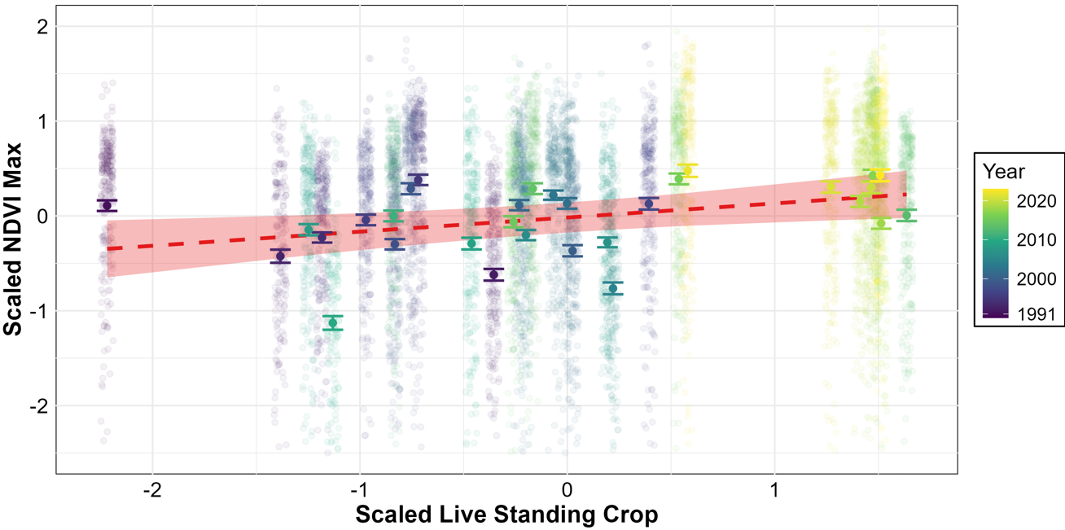**Figure 2:** Average annual NDVIMAX in calcareous grassland plotted against the average maximum live standing crop biomass sampled at six locations in calcareous grassland across the study area. Both variables have been scaled. Red dashed line indicates model prediction, shaded area indicates 95% confidence interval. Larger points with error bars indicate the average standing crop across the six plots for a given year. Colour indicates year.

**Landsat NDVIMax vs MODIS EVIAmp**

There was a significant positive relationship between EVIAmp and NDVIMax, indicating that increases in EVI, measured using MODIS, are associated with higher NDVI values measured by Landsat (Table 2).

|  |  |  |  |  |  |
| --- | --- | --- | --- | --- | --- |
| Component | Estimate | Std. Error | p-value | Variance | % Total Variance |
| Fixed Effects |  |  |  |  |  |
| (Intercept) | 0.671 | 0.011 | **<0.001** | — | — |
| EVI Amplitude | 0.036 | 0.015 | **0.0126** | — | — |
| Random Effects |  |  |  |  |  |
| Pixel | — | — | — | 0.00309 | 79.4% |
| Year | — | — | — | 0.00067 | 17.2% |
| Residual | — | — | — | 0.00022 | 3.4% |

**Table 2:** Parameter estimates for the linear mixed model testing the association between NDVIMax and EVIAmp, including random effects of year and pixel. Variance components reflect the proportion of total variance attributable to each random effect. Fixed effects significant at the 5% level are marked in bold in the p-value column.

Decomposing this association into spatial vs temporal contributions revealed significant positive relationships between NDVIMax and both mean and relative EVIAmp. A strong positive association was found between mean EVIAmp and NDVIMax, such that pixels with higher long-term EVI variability exhibited higher peak NDVI values (Table 3). Additionally, year-to-year deviations from a pixel's average EVIAmp were positively correlated with NDVIMax, though this effect was smaller in magnitude. These findings suggest that both persistent spatial differences in EVIAmp and interannual fluctuations contribute to variations in peak vegetation greenness.

|  |  |  |  |  |  |
| --- | --- | --- | --- | --- | --- |
| Component | Estimate | Std. Error | p-value | Variance | % Total Variance |
| Fixed Effects |  |  |  |  |  |
| (Intercept) | 0.379 | 0.028 | **<0.001** | — | — |
| Mean EVI Amplitude | 0.996 | 0.090 | **<0.001** | — | — |
| Relative EVI Amplitude | 0.029 | 0.015 | **0.0463** | — | — |
| Random Effects |  |  |  |  |  |
| Pixel | — | — | — | 0.00087 | 53.7% |
| Year | — | — | — | 0.00067 | 41.5% |
| Residual | — | — | — | 0.00022 | 4.8% |

**Table 3:** Parameter estimates for the linear mixed model testing the association between NDVIMax and EVIAmp using mean and relative EVIAmp to disentangle the spatial and interannual effects, including random effects of year and pixel. Variance components reflect the proportion of total variance attributable to each random effect. Fixed effects significant at the 5% level are marked in bold in the p-value column.

**Temporal trend in live standing crop**

There was a significant positive effect of year on mean June/July live standing crop (Table 4, Figure 3). This indicates that, on average, the standing crop increased by approximately 18 g/m2 per year over the study period, after accounting for variability between plots. The random intercept for plot accounted for 20.5% of the total variance, reflecting some plot-specific differences in standing crop levels.

|  |  |  |  |  |  |
| --- | --- | --- | --- | --- | --- |
| Component | Estimate | Std. Error | p-value | Variance | % Total Variance |
| Fixed Effects |  |  |  | — | — |
| (Intercept) | -23.322 | 3.478 | **< 0.001** | — | — |
| Year | 0.018 | 0.0019 | **< 0.001** | — | — |
| Random Effects |  |  |  |  |  |
| Plot (Intercept) | — | — | — | 0.0185 | 19.6% |
| Residual | — | — | — | 0.0761 | 80.4% |

**Table 4:** Linear mixed model of the temporal trend in annual average Live Standing Crop across July and August. Includes random effect of vegetation cage (Plot). Fixed effects significant at the 5% level are marked in bold in the p-value column.

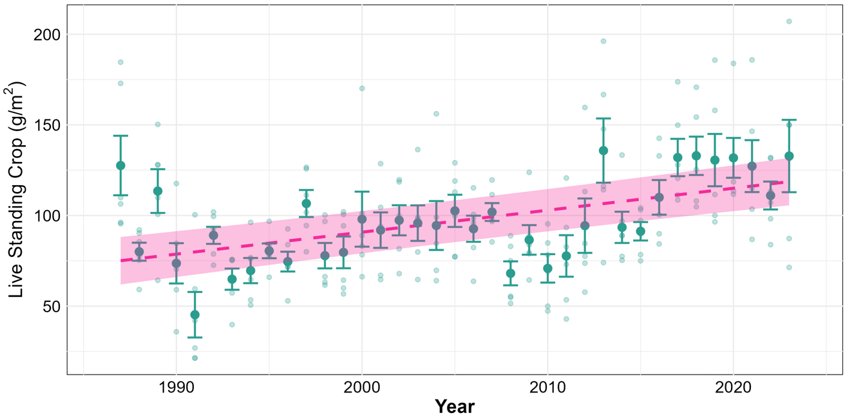**Figure 3:** Temporal trend in average maximum live standing crop biomass sampled at six plots on calcareous grassland across the study area. Pink dashed line indicates model prediction, with shaded area a 95% confidence interval. Larger points with error bars indicate the average standing crop across the six plots. Smaller, faded points indicate the plots.

**Temporal trends in MODIS EVI**

There was a significant positive trend in EVI amplitude over time (Figure 4; Table 5), indicating an overall increase in vegetation greenness across the study area between 2000 and 2023 detected by MODIS. Spatial variability was far greater than inter-annual variability, reflecting the heterogeneous nature of vegetation dynamics across the landscape. Neither wet grass nor wet heath differed significantly from blanket bog (the reference group). That we were unable to detect differences between vegetation types is unsurprising given the small number of pixels for each vegetation type and the fact that most MODIS pixels over the study area, due to their size, tend to cover several vegetation types; this highlights the utility of the Landsat dataset.

|  |  |  |  |  |  |
| --- | --- | --- | --- | --- | --- |
| Component | Estimate | Std. Error | p-value | Variance | % Total Variance |
| Fixed Effects |  |  |  |  |  |
| (Intercept) | –4.670 | 1.291 | **0.002** | — | — |
| Year | 0.003 | 0.001 | **0.001** | — | — |
| Wet Grass | 0.028 | 0.025 | 0.268 | — | — |
| Wet Heath | –0.001 | 0.016 | 0.529 | — | — |
| Random Effects |  |  |  |  |  |
| Pixel | — | — | — | 0.00243 | 65.3% |
| Year | — | — | — | 0.00035 | 9.4% |
| Residual | — | — | — | 0.00104 | 25.3% |

**Table 5:** Parameter estimates for the linear mixed model of EVI using MODIS data, including random effects of year and pixel.

**Figure 4:** Model estimates of EVI Amplitude for the three most abundant vegetation types from MODIS data. Trend lines are overlaid on the individual pixel estimates. Shaded areas indicate 95% confidence intervals for the associated group.

There was no significant effect of year on EVIMaturityDOY, meaning we found no evidence that phenology on the island has changed in the period 2000 – 2022 (Figure 5; Table 6). Random effects revealed substantial inter-annual variability compared to spatial variability, indicating that year-to-year environmental factors had a stronger influence on maturity than spatial heterogeneity.

|  |  |  |  |  |  |
| --- | --- | --- | --- | --- | --- |
| Component | Estimate | Std. Error | p-value | Variance | % Total Variance |
| Fixed Effects |  |  |  | — | — |
| (Intercept) | 435.914 | 407.187 | 0.297 | — | — |
| Year (scaled) | –0.126 | 0.202 | 0.542 | — | — |
| Wet Grass | –0.057 | 1.226 | 0.963 | — | — |
| Wet Heath | 0.722 | 0.783 | 0.360 | — | — |
| Random Effects |  |  |  |  |  |
| Pixel | — | — | — | 4.178 | 5.0% |
| Year | — | — | — | 35.600 | 42.6% |
| Residual | — | — | — | 43.719 | 52.4% |

**Table 6:** Parameter estimates for the linear mixed model predicting vegetation maturity (used as a proxy for the date of maximum EVI) using MODIS data. Maturity date is modelled as a function of year (scaled) and vegetation type, with random intercepts for pixel and year. Variance components reflect the proportion of total variance attributable to each random effect.

**Figure 5:** Model estimates of EVI Maturity date from MODIS data. Individual pixel estimates are coloured by vegetation type. Coloured trendlines depict model predictions for each vegetation type. The shaded area around the trendlines indicate the 95% confidence intervals.

**Temporal trends in Landsat NDVIMax**

Model comparison using likelihood ratio tests revealed significant improvements in model fit with increasing complexity. Including vegetation type as a fixed effect significantly improved the model compared to the baseline without vegetation groups (χ² = 160.68, df = 5, p < 0.001), indicating that NDVIMax differs among vegetation types. Adding the interaction between year and vegetation type significantly improved fit again (χ² = 426.66, df = 5, p < 0.001), demonstrating that temporal trends in NDVIMax vary across vegetation groups.

The final interaction model showed a small but significant positive overall effect of year, reflecting a general greening trend across the study period (Figure 6; Table 7). Wet grassland exhibited significantly higher NDVIMax than the reference vegetation type, acid grassland, while other vegetation groups did not differ significantly at the 5% level. Random effect variance partitioning highlights substantial spatial and temporal heterogeneity in vegetation greenness, with the spatial component dominating the overall model variance structure (Table 7). This highlights the importance of spatial structure in explaining NDVI variation. The significant interaction terms revealed contrasting temporal trends among vegetation types (Figure 6; Figure S9; Table 7). Wet grassland exhibited a significantly stronger increase in NDVIMax over time compared to acid grassland, while blanket bog and wet heath showed significant negative interactions, indicating a slower increase in NDVIMax in these groups which are less preferred by deer. Other interaction terms were not statistically significant. These results suggest that temporal trends in vegetation greenness are not uniform across vegetation types, with wet grassland in particular greening more rapidly than other groups (this can be seen more clearly in Figure S9). 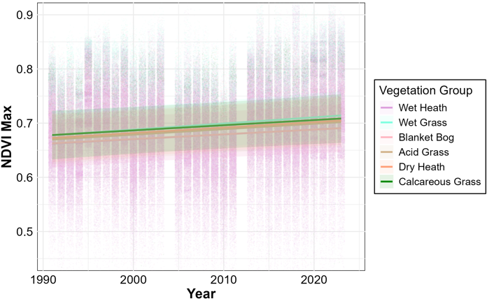

**Figure 6:** Model estimates of NDVI Maximum by vegetation type from Landsat data. Individual pixel estimates are coloured by vegetation type. Trendline predictions from the model with vegetation type and year interactions are overlaid. The shaded area around the trendlines indicate the 95% confidence intervals.

|  |  |  |  |  |  |
| --- | --- | --- | --- | --- | --- |
| Component | Estimate | Std. Error | p-value | Variance | % Total Variance |
| Fixed Effects |  |  |  |  |  |
| (Intercept) | 0.686 | 0.022 | **<0.001** | — | — |
| Year (scaled) | 0.0099 | 0.0043 | **0.023** | — | — |
| Blanket Bog | –0.0091 | 0.0052 | 0.083 | — | — |
| Calcareous Grass | 0.0075 | 0.0058 | 0.197 | — | — |
| Dry Heath | 0.0029 | 0.0059 | 0.617 | — | — |
| Wet Grass | 0.0102 | 0.0051 | **0.047** | — | — |
| Wet Heath | –0.0093 | 0.0051 | 0.067 | — | — |
| Year × Blanket Bog | –0.0013 | 0.0004 | **0.003** | — | — |
| Year × Calcareous Grass | –0.0005 | 0.0005 | 0.310 | — | — |
| Year × Dry Heath | 0.0000 | 0.0005 | 0.974 | — | — |
| Year × Wet Grass | 0.0013 | 0.0004 | **0.003** | — | — |
| Year × Wet Heath | –0.0011 | 0.0004 | **0.011** | — | — |
| Random Effects |  |  |  |  |  |
| Spatial | — | — | — | 0.00559 | 72.0% |
| Pixel | — | — | — | 0.00099 | 12.8% |
| Year | — | — | — | 0.00057 | 7.4% |
| Residual | — | — | — | 0.00061 | 7.8% |

**Table 7:** Parameter estimates for the linear mixed model of NDVIMax using Landsat data. NDVI is modelled as a function of year (scaled) and vegetation type, with an interaction term included. Acid Grass is the reference vegetation type. Significant fixed effects are marked in bold in the p-value column. Variance components reflect the proportion of total variance attributable to each random effect.

**Discussion**

To assess the reliability and ecological relevance of satellite-derived vegetation indices, we validated our Landsat-derived NDVI measures against long-term field data: we showed that annual variation in peak NDVI was positively correlated with mid-summer (June-July) vegetation biomass (live standing crop), confirming that the remote-sensed data correspond meaningfully to on-the-ground vegetation change. Although the Landsat dataset underwent extensive pre-processing – particularly cross-sensor calibration and phenological spline fitting – we find reassurance in the resulting data's significant association with a pre-processed, single-sensor MODIS EVI product. This supports the methodological soundness of our Landsat pipeline and affirms its utility for assessing peak vegetation greenness at finer spatial resolution than is possible using MODIS.

Our ground-truth findings align with the conclusions of Borowik et al. (2013), who emphasised the need for field validation when using NDVI as a proxy for forage availability in eastern Poland. Their study demonstrated a strong positive relationship between NDVI and ground vegetation biomass in open "field" habitats during summer, comparable to our findings in Rum’s calcareous grasslands. However, their study only collected biomass data across two years, in 2007 and 2008, a relatively limited time frame for understanding longer-term trends. In contrast, our study incorporates biomass data collected over three decades, providing a more robust and temporally comprehensive validation of NDVI as a proxy for vegetation biomass. This extended period of field data enables us to better assess the consistency of the NDVI–biomass relationship over time. In this respect, our study contributes a valuable case where NDVI-derived greenness is meaningfully grounded in direct measures of vegetation biomass. This validation is essential, as it confirms that remotely sensed indices can serve as ecologically relevant proxies for vegetation greenness in this habitat. This positions us to assess and interpret vegetation trends with a level of confidence rarely achievable in comparable studies.

We provide evidence that annual peak vegetation greenness on the Isle of Rum has increased over the past almost forty years, as indicated by significant temporal trends in models Landsat NDVI, MODIS EVI, and standing crop calculated from field-measured vegetation data. This suggests long-term shifts in vegetation productivity, with potentially important implications for red deer on the Isle of Rum (Hasik et al., 2025). Our results suggest that resource availability for deer has generally improved over time, but the ecological consequences depend on how different vegetation types – both those preferred by deer and those they avoid – have responded to these trends. Our analyses revealed small but significant variations in the rate of change in NDVIMax among different vegetation types. This suggests that while overall greening trends are apparent, the extent and rate of vegetation change are not uniform across the landscape; this is consistent with a recent study focused on the arctic tundra biome (Berner et al., 2020) and wider global greening trends (Cortés et al., 2021; [Correa-Díaz](https://www.researchgate.net/profile/Arian-Correa-Diaz?_tp=eyJjb250ZXh0Ijp7ImZpcnN0UGFnZSI6InB1YmxpY2F0aW9uIiwicGFnZSI6InB1YmxpY2F0aW9uIn19), 2021). Among deer-preferred habitats, acid grassland and wet grassland exhibited some of the most pronounced increases in NDVIMax, aligning with the findings of a recent analysis of Soay sheep (*Ovis aries*) on St. Kilda (Pakeman et al., 2024). Calcareous grassland, though consistently among the greenest habitats, showed more modest gains; this may reflect strong grazing pressure limiting vegetation growth in this area. Greening in unpreferred habitats may provide clearer signals of broader environmental change, indicating that system-wide drivers (i.e., higher ambient temperatures) are likely enhancing vegetation productivity across the landscape.

Our findings provide important ecological context for demographic changes observed in the deer population. For instance, Moyes et al. (2011) and Bonnet et al. (2019) detected a two-week advance in red deer parturition dates over recent decades. Our evidence of long-term increases in vegetation greenness – particularly in habitats favoured by deer and validated by ground-based biomass data – offers a plausible ecological mechanism that could support, and potentially drive, such phenological shifts, by way of more food leading to better condition and therefore potentially earlier ovulation. A significant advantage of the Landsat dataset is the ability to analyse vegetation dynamics at a much finer spatial resolution than was previously possible in our study system. By generating a 30m resolution dataset of the study area, we can capture spatial variation in vegetation, providing a more detailed understanding of habitat quality and its potential effects on red deer ecology. Future studies can capitalise on this relatively high spatial resolution by linking it with individual-level data on deer locations, enabling us to conduct individual-level analyses that explore how spatiotemporal variation in vegetation influences life-history traits and population dynamics. Although beyond the immediate scope of this study, we expect the vegetation dataset we have generated to be valuable for a wide range of future analyses, including investigations into movement patterns, foraging decisions, parasite dynamics (Hasik et al., 2025), habitat selection, and climate-driven ecological changes on Rum.

Although we detected clear trends in peak greenness, we found no reliable evidence of shifts in vegetation phenology over time. This lack of signal may reflect data limitations rather than a true absence of phenological change, especially given well-documented trends toward earlier spring phenology (Parmesan, 2007). On Rum, the presence of data gaps due to poor atmospheric conditions, particularly cloud cover, heavily impacted the availability of high-quality Landsat images available. Additionally, the scan line correction fault on Landsat 7 from 2003 (Storey et al., 2005), corrected in 2012, resulted in missing data, requiring the use of "ghost observations" borrowed from neighbouring years. While this approach helps fill in gaps, it introduces temporal autocorrelation, limiting the reliability of among-year analyses and potentially affecting short-term trends. We opted not to model phenology using Landsat data, due to concerns over robustness driven by data gaps and sparse temporal coverage, which resulted in unreliable NDVIMaxDOY estimates. Frequent cloud cover also likely reduced the quality and quantity of observations in the annualised MODIS product, limiting our ability to detect trends with confidence – though this is somewhat offset by the data being collected daily. There was high interannual variation EVIMaturityDOY, which may indicate a degree of noise or instability in these data. This suggests that the phenological spline fitting process used to derive these metrics could be sensitive to input variation and may introduce artefactual patterns – a concern we also encountered when fitting splines to our Landsat data. Unfortunately, we were unable to formally assess the sensitivity of these MODIS-derived phenology metrics to data density or quality, as the raw input data were not available. The dearth of cloud-free images, combined with the need to interpolate missing data, reduces the accuracy of detecting precise seasonal shifts in vegetation growth. Annual average vegetation indices are relatively coarse metrics which are perhaps more easily estimable with sparse data than phenology metrics such as the precise timing of green-up, which could be heavily influenced by a single datapoint.

This highlights the trade-offs inherent in using remote sensing data for ecological studies: while the long-term trends are robust, short-term or highly seasonal patterns may be less reliable, and the data are not appropriate for these types of analyses. A potential solution for future analyses is to incorporate imagery from the Sentinel-2 satellites, which offers a higher spatial resolution of 10 m² and captures images every five days, increasing the likelihood of obtaining cloud-free observations. The improved temporal frequency and finer spatial scale would enhance the accuracy of vegetation monitoring. However, Sentinel-2 was launched in 2016, meaning it currently lacks the long-term historical coverage provided by Landsat, limiting its use for assessing vegetation trends over multiple decades.

Our study further highlights the crucial role of cross-calibration in maintaining temporal consistency across satellite datasets (Berner et al., 2020). This process is not a minor technical step – it is foundational to ensuring that observed trends reflect ecological reality rather than artifacts of differing sensor sensitivities or spectral responses. We demonstrated that across Landsat sensors, substantial differences in vegetation indices can arise without proper calibration. This introduces the risk of misinterpreting shifts in vegetation dynamics if methodological discrepancies are mistaken for real-world change. As more high-resolution Earth observation data becomes available from platforms like Sentinel-2 and upcoming missions, ensuring compatibility across sensors will be increasingly vital for robust, multi-decadal ecological analyses. Our findings reinforce the notion that methodological rigour in calibration is not just good practice – it is a precondition for credible inference about long-term environmental change.

# **Conclusion**

Our study demonstrates that peak vegetation greenness on Rum has increased over the past three decades, with this trend evident across multiple satellite-based systems and validated through long-term vegetation data collected in the field. These findings suggest an overall increase in vegetation productivity, with potential consequences, particularly in improving foraging conditions for red deer. While not all vegetation types have changed at the same rate, habitats favoured by deer – such as acid and wet grasslands – have seen some of the most marked greening, offering a plausible ecological mechanism for demographic shifts observed in the population, such as earlier calving (Bonnet et al., 2019).

By ground truthing remotely sensed NDVI data with field-based measures of vegetation, our study provides rare and robust biological validation of satellite-derived vegetation metrics. This strengthens confidence in the ecological relevance of long-term remote sensing data and highlights the potential of integrating satellite observations with detailed, individual-based data in wild animal populations. Our work also underscores the methodological challenges of using satellite remote sensing in cloud-prone, heterogeneous landscapes, particularly for detecting phenological trends.

A key strength of our study lies in the spatial resolution achieved through Landsat data, allowing vegetation change to be assessed at the 30 m pixel scale across the study area. This resolution enables us to quantify the forage availability in individual deer habitats through existing long-term census and location data, enabling individual level analyses of the effects of variation in forage. The resulting dataset represents a valuable resource for future research on red deer ecology, with potential applications across demography, population dynamics, life-history traits, parasite interactions, and responses to climate-driven environmental change.

Beyond its immediate application to the Rum system, our study offers a practical blueprint for integrating satellite-derived vegetation indices with field-based validation in long-term ecological research. By demonstrating how to overcome challenges related to sensor calibration, cloud cover, and phenology extraction, we provide a replicable framework for using remote sensing to monitor ecological change with biological credibility. As high-resolution Earth observation platforms like Sentinel-2 continue to improve data availability, such approaches will be increasingly important for understanding how ecosystems respond to environmental change over time and space.

Ultimately, our findings illustrate both the power and the limitations of remote sensing in long-term ecological research. With careful calibration, validation, and interpretation, satellite data can reveal meaningful environmental change across decades, as it has on Rum, enhancing our understanding of how ecosystems respond to climatic and biotic pressures over time.

# **Bibliography**

Alademomi, Alfred S., Chukwuma J. Okolie, Olagoke E. Daramola, Raphael O. Agboola, and Tosin J. Salami. 2020. “Assessing the Relationship of LST, NDVI and EVI with Land Cover Changes in the Lagos Lagoon Environment.” *Quaestiones Geographicae* 39 (3): 87–109. <https://doi.org/10.2478/quageo-2020-0025>.

Albery, Gregory F., Fiona Kenyon, Alison Morris, Sean Morris, Daniel H. Nussey, and Josephine M. Pemberton. 2018. “Seasonality of Helminth Infection in Wild Red Deer Varies between Individuals and between Parasite Taxa.” *Parasitology* 145 (11): 1410–20. <https://doi.org/10.1017/S0031182018000185>.

Albery, Gregory F., Lucinda Kirkpatrick, Josh A. Firth, and Shweta Bansal. 2021. “Unifying Spatial and Social Network Analysis in Disease Ecology.” *Journal of Animal Ecology* 90 (1): 45–61. <https://doi.org/10.1111/1365-2656.13356>.

Bahrami, Hazhir, Heather McNairn, Masoud Mahdianpari, and Saeid Homayouni. 2022. “A Meta-Analysis of Remote Sensing Technologies and Methodologies for Crop Characterization.” *Remote Sensing* 14 (22): 5633. <https://doi.org/10.3390/rs14225633>.

Bates, Douglas, Martin Maechler, Ben Bolker, Steve Walker (2015). Fitting Linear Mixed-Effects Models

Using lme4. Journal of Statistical Software, 67(1),

1-48. doi:10.18637/jss.v067.i01.

Belousova, Irina P., Malgorzata Krasinska, Zbigniew A. Krasinski, Wanda Olech, and Zdzislaw Pucek. n.d. “European Bison : Status Survey and Conservation Action Plan | Policy Commons.” Accessed August 11, 2024. <https://policycommons.net/artifacts/1376673/european-bison/1990940/>.

Berner, Logan T., Jakob J. Assmann, Signe Normand, and Scott J. Goetz. 2023. “‘LandsatTS’: An R Package to Facilitate Retrieval, Cleaning, Cross-Calibration, and Phenological Modeling of Landsat Time Series Data.” *Ecography* 2023 (9): e06768. <https://doi.org/10.1111/ecog.06768>.

Bonnet, Timothée, Michael B. Morrissey, Alison Morris, Sean Morris, Tim H. Clutton-Brock, Josephine M. Pemberton, and Loeske E. B. Kruuk. 2019. “The Role of Selection and Evolution in Changing Parturition Date in a Red Deer Population.” *PLoS Biology* 17 (11): e3000493. <https://doi.org/10.1371/journal.pbio.3000493>.

Borowik, Tomasz, Nathalie Pettorelli, Leif Sönnichsen, and Bogumiła Jędrzejewska. 2013. “Normalized Difference Vegetation Index (NDVI) as a Predictor of Forage Availability for Ungulates in Forest and Field Habitats.” *European Journal of Wildlife Research* 59 (5): 675–82. <https://doi.org/10.1007/s10344-013-0720-0>.

Brooks, Mollie E., Kasper Kristensen, Koen J. van Benthem, Arni Magnusson, Casper W. Berg, Anders Nielsen, Hans J. Skaug, Martin Maechler and Benjamin M. Bolker (2017). glmmTMB Balances Speed

and Flexibility Among Packages for Zero-inflate Generalized Linear Mixed Modeling. The R Journal,

9(2), 378-400. doi: 10.32614/RJ-2017-066.

Clutton-Brock, Tim H., and J. M. Pemberton. 2004. *Soay Sheep: Dynamics and Selection in an Island Population*. Cambridge New York: Cambridge University Press.

Clutton-Brock, Tim, and Ben C Sheldon. 2010. “Individuals and Populations: The Role of Long-Term, Individual-Based Studies of Animals in Ecology and Evolutionary Biology.” *Trends in Ecology & Evolution*, Special Issue: Long-term ecological research, 25 (10): 562–73. <https://doi.org/10.1016/j.tree.2010.08.002>.

Clutton-Brock, Tim H., F. E. Guinness, S. D. Albon. 1982. “Red Deer: Behavior and Ecology of Two Sexes. Wildlife Behavior and Ecology.” <https://doi.org/10.1086/413632>.

Cole, Ella F., Peter R. Long, Przemyslaw Zelazowski, Marta Szulkin, and Ben C. Sheldon. 2015. “Predicting Bird Phenology from Space: Satellite-Derived Vegetation Green-up Signal Uncovers Spatial Variation in Phenological Synchrony between Birds and Their Environment.” *Ecology and Evolution* 5 (21): 5057–74. <https://doi.org/10.1002/ece3.1745>.

Correa-Díaz, A., M. E. Romero-Sánchez, and J. Villanueva-Díaz. 2021. “The Greening Effect Characterized by the Normalized Difference Vegetation Index Was Not Coupled with Phenological Trends and Tree Growth Rates in Eight Protected Mountains of Central Mexico.” *Forest Ecology and Management* 496 (September):119402. <https://doi.org/10.1016/j.foreco.2021.119402>.

Cortés, José, Miguel D. Mahecha, Markus Reichstein, Ranga B. Myneni, Chi Chen, and Alexander Brenning. 2021. “Where Are Global Vegetation Greening and Browning Trends Significant?” *Geophysical Research Letters* 48 (6): e2020GL091496. <https://doi.org/10.1029/2020GL091496>.

Coulson, Tim, Fiona Guinness, Josephine Pemberton, and Tim Clutton-Brock. 2004. “THE DEMOGRAPHIC CONSEQUENCES OF RELEASING A POPULATION OF RED DEER FROM CULLING.” *Ecology* 85 (2): 411–22. <https://doi.org/10.1890/03-0009>.

Eastman, J. Ronald, Florencia Sangermano, Elia A. Machado, John Rogan, and Assaf Anyamba. 2013. “Global Trends in Seasonality of Normalized Difference Vegetation Index (NDVI), 1982–2011.” *Remote Sensing* 5 (10): 4799–4818. <https://doi.org/10.3390/rs5104799>.

Friedl, Mark, Josh Gray, and Damien Sulla-Menashe. 2022. “MODIS/Terra+Aqua Land Cover Dynamics Yearly L3 Global 500m SIN Grid V061.” NASA EOSDIS Land Processes Distributed Active Archive Center. <https://doi.org/10.5067/MODIS/MCD12Q2.061>.

Gao, Xiang, A.R. Huete, and K. Didan. 2003. “Multisensor Comparisons and Validation of MODIS Vegetation Indices at the Semiarid Jornada Experimental Range.” *IEEE Transactions on Geoscience and Remote Sensing* 41 (10): 2368–81. <https://doi.org/10.1109/TGRS.2003.813840>.

Garant, Dany. 2020. “Natural and Human-Induced Environmental Changes and Their Effects on Adaptive Potential of Wild Animal Populations.” *Evolutionary Applications* 13 (6): 1117–27. <https://doi.org/10.1111/eva.12928>.

Gordon, I. J. 1989. “Vegetation Community Selection by Ungulates on the Isle of Rhum. II. Vegetation Community Selection.” *Journal of Applied Ecology* 26 (1): 53–64. <https://doi.org/10.2307/2403650>.

Grant, Peter R., and B. Rosemary Grant. 2002. “Unpredictable Evolution in a 30-Year Study of Darwin’s Finches.” *Science (New York, N.Y.)* 296 (5568): 707–11. <https://doi.org/10.1126/science.1070315>.

Gutman, Garik, and A Ignatov. 1998. “The Derivation of the Green Vegetation Fraction from NOAA/AVHRR Data for Use in Numerical Weather Prediction Models.” *International Journal of Remote Sensing* 19 (May). <https://doi.org/10.1080/014311698215333>.

Hamel, Sandra, Mathieu Garel, Marco Festa-Bianchet, Jean-Michel Gaillard, and Steeve D. Côté. 2009. “Spring Normalized Difference Vegetation Index (NDVI) Predicts Annual Variation in Timing of Peak Faecal Crude Protein in Mountain Ungulates.” *Journal of Applied Ecology* 46 (3): 582–89. <https://doi.org/10.1111/j.1365-2664.2009.01643.x>.

Huete, A, C Justice, and H Liu. 1994. “Development of Vegetation and Soil Indices for MODIS-EOS.” *Remote Sensing of Environment* 49 (3): 224–34. <https://doi.org/10.1016/0034-4257(94)90018-3>.

Huete, Alfredo, K. Didan, Tomoaki Miura, Edna Rodriguez, X Gao, and L.G. Ferreira. 2002. “Overview of the Radiometric and Biophysical Performance of the MODIS Vegetation Indices.” *Remote Sensing of Environment* 83 (November):195–213. <https://doi.org/10.1016/S0034-4257(02)00096-2>.

Hufkens (2022). The MODISTools package: an interface to the MODIS Land Products Subsets Web Services <https://github.com/ropensci/MODISTools>

Hurley, Mark A., Mark Hebblewhite, Jean-Michel Gaillard, Stéphane Dray, Kyle A. Taylor, W. K. Smith, Pete Zager, and Christophe Bonenfant. 2014. “Functional Analysis of Normalized Difference Vegetation Index Curves Reveals Overwinter Mule Deer Survival Is Driven by Both Spring and Autumn Phenology.” *Philosophical Transactions of the Royal Society B: Biological Sciences* 369 (1643): 20130196. <https://doi.org/10.1098/rstb.2013.0196>.

Jarchow, Christopher J., Kamel Didan, Armando Barreto-Muñoz, Pamela L. Nagler, and Edward P. Glenn. 2018. “Application and Comparison of the MODIS-Derived Enhanced Vegetation Index to VIIRS, Landsat 5 TM and Landsat 8 OLI Platforms: A Case Study in the Arid Colorado River Delta, Mexico.” *Sensors* 18 (5): 1546. <https://doi.org/10.3390/s18051546>.

Johnson, Heather E., David D. Gustine, Trevor S. Golden, Layne G. Adams, Lincoln S. Parrett, Elizabeth A. Lenart, and Perry S. Barboza. 2018. “NDVI Exhibits Mixed Success in Predicting Spatiotemporal Variation in Caribou Summer Forage Quality and Quantity.” *Ecosphere* 9 (10): e02461. <https://doi.org/10.1002/ecs2.2461>.

Kerr, Jeremy T., and Marsha Ostrovsky. 2003. “From Space to Species: Ecological Applications for Remote Sensing.” *Trends in Ecology & Evolution* 18 (6): 299–305. <https://doi.org/10.1016/S0169-5347(03)00071-5>.

Manson, Steven, Dudley Bonsal, Melinda Kernik, and Eric Lambin. 2015. “Geographic Information Systems and Remote Sensing.” *International Encyclopedia of the Social & Behavioral Sciences*, December. <https://doi.org/10.1016/B978-0-08-097086-8.91027-4>.

Moore, Emily K., Andrea J. Britton, Glenn Iason, Josephine Pemberton, and Robin J. Pakeman. 2015. “Landscape-Scale Vegetation Patterns Influence Small-Scale Grazing Impacts.” *Biological Conservation* 192 (December):218–25. <https://doi.org/10.1016/j.biocon.2015.09.019>.

Moyes, Kelly, Daniel H. Nussey, Michelle N. Clements, Fiona E. Guinness, Alison Morris, Sean Morris, Josephine M. Pemberton, Loeske E. B. Kruuk, and Tim H. Clutton-Brock. 2011. “Advancing Breeding Phenology in Response to Environmental Change in a Wild Red Deer Population.” *Global Change Biology* 17 (7): 2455–69. <https://doi.org/10.1111/j.1365-2486.2010.02382.x>.

Mutanga, O., Masenyama, A., & Sibanda, M. (2023). Spectral saturation in the remote sensing of high-density vegetation traits: A systematic review of progress, challenges, and prospects. ISPRS Journal of Photogrammetry and Remote Sensing, 198, 297–309. <https://doi.org/10.1016/j.isprsjprs.2023.03.010>

Pacifici, Michela, Wendy B. Foden, Piero Visconti, James E. M. Watson, Stuart H. M. Butchart, Kit M. Kovacs, Brett R. Scheffers, et al. 2015. “Assessing Species Vulnerability to Climate Change.” *Nature Climate Change* 5 (3): 215–24. <https://doi.org/10.1038/nclimate2448>.

Pakeman, Robin J., Ian Stevenson, Jill Pilkington, et al. 2024. “Plant Community-Specific Greening Patterns Predict Population Size Increases in a Temperate Herbivore.” *Oikos* 2024 (12): e10551. <https://doi.org/10.1111/oik.10551>.

Parmesan, Camille. 2006. “Ecological and Evolutionary Responses to Recent Climate Change.” *Annual Review of Ecology, Evolution, and Systematics* 37 (Volume 37, 2006): 637–69. <https://doi.org/10.1146/annurev.ecolsys.37.091305.110100>.

Parmesan, Camille. 2007. “Influences of Species, Latitudes and Methodologies on Estimates of Phenological Response to Global Warming.” *Global Change Biology* 13 (9): 1860–72. <https://doi.org/10.1111/j.1365-2486.2007.01404.x>.

Pemberton, Josephine M., Loeske E. B. Kruuk, and Tim Clutton-Brock. 2022. “The Unusual Value of Long-Term Studies of Individuals: The Example of the Isle of Rum Red Deer Project.” *Annual Review of Ecology, Evolution, and Systematics* 53 (Volume 53, 2022): 327–51. <https://doi.org/10.1146/annurev-ecolsys-012722-024041>.

Perrins, C. M. 1965. “Population Fluctuations and Clutch-Size in the Great Tit, Parus Major L.” *The Journal of Animal Ecology* 34 (3): 601. <https://doi.org/10.2307/2453>.

Pettorelli, N, S Ryan, T Mueller, N Bunnefeld, B Jedrzejewska, M Lima, and K Kausrud. 2011. “The Normalized Difference Vegetation Index (NDVI): Unforeseen Successes in Animal Ecology.” *Climate Research* 46 (1): 15–27. <https://doi.org/10.3354/cr00936>.

Pettorelli, Nathalie. 2013. “The Normalized Difference Vegetation Index.” *The Normalized Difference Vegetation Index*, October, 1–208. <https://doi.org/10.1093/acprof:osobl/9780199693160.001.0001>.

Pettorelli, Nathalie, Jean-Michel Gaillard, Atle Mysterud, Patrick Duncan, Nils Chr. Stenseth, Daniel Delorme, Guy Van Laere, Carole Toïgo, and Francois Klein. 2006. “Using a Proxy of Plant Productivity (NDVI) to Find Key Periods for Animal Performance: The Case of Roe Deer.” *Oikos* 112 (3): 565–72. <https://doi.org/10.1111/j.0030-1299.2006.14447.x>.

Pettorelli, Nathalie, Jon Olav Vik, Atle Mysterud, Jean-Michel Gaillard, Compton J. Tucker, and Nils Chr Stenseth. 2005. “Using the Satellite-Derived NDVI to Assess Ecological Responses to Environmental Change.” *Trends in Ecology & Evolution* 20 (9): 503–10. <https://doi.org/10.1016/j.tree.2005.05.011>.

Piedallu, C., V. Chéret, J. P. Denux, V. Perez, J. S. Azcona, I. Seynave, and J. C. Gégout. 2019. “Soil and Climate Differently Impact NDVI Patterns According to the Season and the Stand Type.” *Science of The Total Environment* 651 (February):2874–85. <https://doi.org/10.1016/j.scitotenv.2018.10.052>.

Pol, Martijn van de, and Jonathan Wright. 2009. “A Simple Method for Distinguishing Within- versus between-Subject Effects Using Mixed Models.” *Animal Behaviour* 77 (3): 753–58. <https://doi.org/10.1016/j.anbehav.2008.11.006>.

R Core Team (2024). _R: A Language and Environment for Statistical Computing_. R Foundation for Statistical Computing, Vienna, Austria. https://www.R-project.org/

Reinke, Beth A., David A. W. Miller, and Fredric J. Janzen. 2019. “What Have Long-Term Field Studies Taught Us About Population Dynamics?” *Annual Review of Ecology, Evolution, and Systematics* 50 (Volume 50, 2019): 261–78. <https://doi.org/10.1146/annurev-ecolsys-110218-024717>.

Ripple, William J., and Robert L. Beschta. 2012. “Trophic Cascades in Yellowstone: The First 15  Years after Wolf Reintroduction.” *Biological Conservation* 145 (1): 205–13. <https://doi.org/10.1016/j.biocon.2011.11.005>.

Rose, K. E., T. H. Clutton-Brock, and F. E. Guinness. 1998. “Cohort Variation in Male Survival and Lifetime Breeding Success in Red Deer.” *The Journal of Animal Ecology* 67 (6): 979–86. <https://doi.org/10.1046/j.1365-2656.1998.6760979.x>.

Roy, D. P., H. K. Zhang, J. Ju, J. L. Gomez-Dans, P. E. Lewis, C. B. Schaaf, Q. Sun, J. Li, H. Huang, and V. Kovalskyy. 2016. “A General Method to Normalize Landsat Reflectance Data to Nadir BRDF Adjusted Reflectance.” *Remote Sensing of Environment* 176 (April):255–71. <https://doi.org/10.1016/j.rse.2016.01.023>.

Santin-Janin, H., M. Garel, J.-L. Chapuis, and D. Pontier. 2009. “Assessing the Performance of NDVI as a Proxy for Plant Biomass Using Non-Linear Models: A Case Study on the Kerguelen Archipelago.” *Polar Biology* 32 (6): 861–71. <https://doi.org/10.1007/s00300-009-0586-5>.

Shukla, Anugya, and Kamal Jain. 2021. “Analyzing the Impact of Changing Landscape Pattern and Dynamics on Land Surface Temperature in Lucknow City, India.” *Urban Forestry & Urban Greening* 58 (March):126877. <https://doi.org/10.1016/j.ufug.2020.126877>.

Stopher, Katie V., Ana I. Bento, Tim H. Clutton-Brock, Josephine M. Pemberton, and Loeske E. B. Kruuk. 2014. “Multiple Pathways Mediate the Effects of Climate Change on Maternal Reproductive Traits in a Red Deer Population.” *Ecology* 95 (11): 3124–38. <https://doi.org/10.1890/13-0967.1>.

Storey, James, Pasquale Scaramuzza, Gail Schmidt, and Julia Barsi. 2005. “LANDSAT 7 SCAN LINE CORRECTOR-OFF GAP-FILLED PRODUCT DEVELOPMENT.”

Thornton, Philip K, Polly J Ericksen, Mario Herrero, and Andrew J Challinor. 2014. “Climate Variability and Vulnerability to Climate Change: A Review.” *Global Change Biology* 20 (11): 3313–28. <https://doi.org/10.1111/gcb.12581>.

Vermote, Eric, Chris Justice, Martin Claverie, and Belen Franch. 2016. “Preliminary Analysis of the Performance of the Landsat 8/OLI Land Surface Reflectance Product.” *Remote Sensing of Environment* Volume 185 (Iss 2): 46–56. <https://doi.org/10.1016/j.rse.2016.04.008>.

Wickham, H. “ggplot2: Elegant Graphics for Data Analysis.” Springer-Verlag New York, 2016.

Zhu, Zhe, and Curtis Woodcock. 2014. “Automated Cloud, Cloud Shadow, and Snow Detection in Multitemporal Landsat Data: An Algorithm Designed Specifically for Monitoring Land Cover Change.” *Remote Sensing of Environment* 152 (September):217–34. <https://doi.org/10.1016/j.rse.2014.06.012>.

Zou, Xiaochen, and Matti Mõttus. 2017. “Sensitivity of Common Vegetation Indices to the Canopy Structure of Field Crops.” *Remote Sensing* 9 (10): 994. <https://doi.org/10.3390/rs9100994>.

Supplementary Information

**Vegetation Groupings**

We used a base map of the vegetation available from the NatureScot Spatial Data Hub with polygons mapped using the National Vegetation Classifications (NVCs) with identified at the subcommunity level. There were 55 subcommunities which map into 32 communities. Table 1 lists the communities found on Rum and their area, both on the island as a whole and within the North Block study area.

|  |  |  |  |  |  |
| --- | --- | --- | --- | --- | --- |
| **Vegetation Group** | **NVC** | **NVC Description** | **Found in North Block?** | **Total Area (m2)** | **Area in North Block (m2)** |
| Acid Grass | U4 | Festuca ovina-Agrostis capillaris-Galium saxatile grassland | 1 | 3,057,122 | 103,890 |
| Blanket Bog | M17 | Scirpus cespitosus-Eriophorum vaginatum blanket mire | 1 | 13,744,544 | 4,742,267 |
| Blanket Bog | M1 | Sphagnum auriculatum bog pool community | 1 | 4,412 | 1,323 |
| Calcareous Grass | CG10 | Festuca ovina-Agrostis capillaris-Thymus praecox grassland | 1 | 2,535,207 | 237,867 |
| Dry Heath | H10 | Calluna vulgaris-Erica cinerea heath | 1 | 13,006,348 | 331,680 |
| Dry Heath | H21 | Calluna vulgaris-Vaccinium myrtillus-Sphagnum capillifolium heath | 1 | 109,263 | 10,032 |
| Dry Heath | H11 | Calluna vulgaris-Carex arenaria heath | 1 | 7,141 | 7,141 |
| Dry Heath | H7 | Calluna vulgaris-Scilla verna heath | 1 | 5,452 | 1,980 |
| Maritime Cliff | MC10 | Festuca rubra-Plantago spp. maritime grassland | 1 | 204,373 | 49,313 |
| Null | Null | NA - not categorised | 1 | 6,619,550 | 353,601 |
| Null | U20 | Pteridium aquilinum-Galium saxatile community | 1 | 407,073 | 3,431 |
| Poor Dry Grass | U5 | Nardus stricta-Galium saxatile grassland | 1 | 1,705,957 | 6,178 |
| Wet Grass | M25 | Molinia caerulea-Potentilla erecta mire | 1 | 6,172,745 | 2,127,229 |
| Wet Grass | M23 | Juncus effusus/acutiflorus-Galium palustre rush-pasture | 1 | 643,726 | 345,480 |
| Wet Grass | M6 | Carex echinata-Sphagnum recurvum/auriculatum mire | 1 | 53,263 | 12,120 |
| Wet Heath | M15 | Scirpus cespitosus-Erica tetralix wet heath | 1 | 60,331,491 | 15,746,162 |
| Acid Grass | MG6 | Lolium perenne-Cynosurus cristatus grassland | 0 | 38,706 | - |
| Alpine Heath | U10 | Carex bigelowii-Racomitrium lanuginosum moss-heath | 0 | 170,112 | - |
| Alpine Heath | U7 | Nardus stricta-Carex bigelowii grass-heath | 0 | 62,314 | - |
| Blanket Bog | M10 | Carex dioica-Pinguicula vulgaris mire | 0 | 88,710 | - |
| Calcareous Grass | CG11 | Festuca ovina-Agrostis capillaris-Alchemilla alpina grassland | 0 | 124,982 | - |
| Calcareous Grass | CG12 | Festuca ovina-Alchemilla alpina-Silene acaulis dwarf-herb community | 0 | 2,621 | - |
| Dry Heath | H20 | Vaccinium myrtillus-Racomitrium lanuginosum heath | 0 | 1,016,504 | - |
| Dry Heath | H14 | Calluna vulgaris-Racomitrium lanuginosum heath | 0 | 593,093 | - |
| Dry Heath | H18 | Vaccinium myrtillus-Deschampsia flexuosa heath | 0 | 65,030 | - |
| Maritime Cliff | MC8 | Festuca rubra-Armeria maritima maritime grassland | 0 | 15,387 | - |
| Null | U17 | Luzula sylvatica-Geum rivale tall-herb community | 0 | 25,784 | - |
| Poor Dry Grass | U6 | Juncus squarrosus-Festuca ovina grassland | 0 | 155,255 | - |
| Wet Grass | M32 | Philonotis fontana-Saxifraga stellaris spring | 0 | 129 | - |
| Woodland | W11 | Quercus petraea-Betula pubescens-Oxalis acetosella woodland | 0 | 53,163 | - |
| Woodland | W23 | Ulex europaeus-Rubus fruticosus scrub | 0 | 12,312 | - |
| Woodland | W17 | Quercus petraea-Betula pubescens-Dicranum majus woodland | 0 | 9,734 | - |

**Table S1:** National Vegetation Classifications for the Isle of Rum based on a map obtained from the NatureScot Spatial Data Hub, including area coverage.

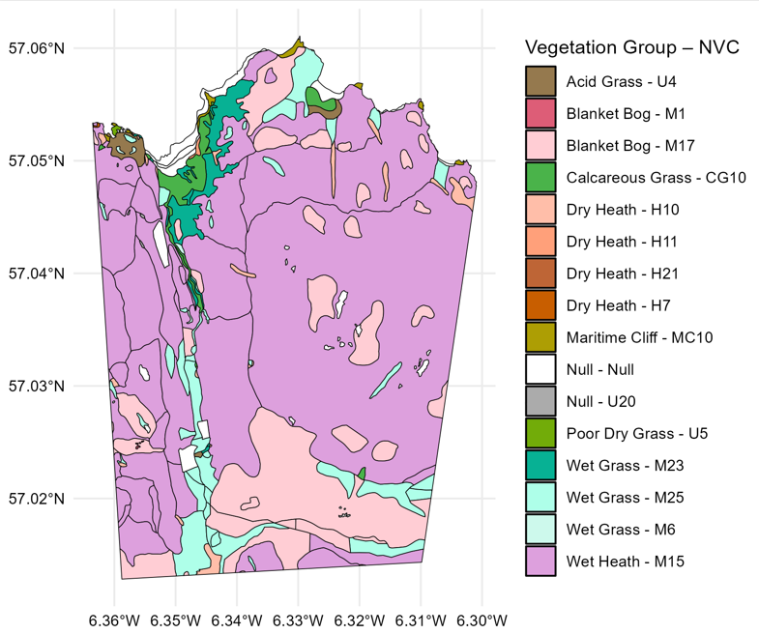

**Figure S1:** Vegetation Map of the study area by National Vegetation Classifications obtained from the NatureScot Spatial Data Hub.

**Vegetation Data**

There were no standing crop data collected for September and November 1987, November 1988, August 2003, November 2000 and May 2020. One plot wasn’t sampled in June 2023. There were six months in the time series during which no data was collected and a few occasions when samples were only taken beside one cage. To allow for different sample sizes the dry biomass of the sample was divided by the number of quadrats sampled at each plot in each month for each year.

The temporal pattern in standing crop within each year (Fig A) shows the annual peak in biomass occurred in June or July, so the mean standing crop across June and July for each year was used. 

**Figure S2:** Average dry biomass of live standing crop for each month in each year plotted across months, colour depicts year.

**Landsat 5, 7 and 8 Cross Calibration**

We used the *LandsatTS* package to cross calibrate the surface reflectance measurements between the three satellites. In summary, the approach involved using Landsat 7 and Landsat 5/8 data from overlapping years to identify corresponding surface reflectance measurements at sample sites, and training a random forest model using 75% of the available data to predict Landsat 7 reflectance based on Landsat 5/8 reflectance values. The remaining 25% of data was used to cross-validate the model. To overcome the lack of sufficient valid NDVI pixel data for model training, we employed the high-latitude training dataset provided by the *LandsatTS* package to bolster the model. To account for potential seasonal and spatial differences between sensors, the random forest models include the midpoint of each 15-day period and the spatial coordinates of each sample as covariates.

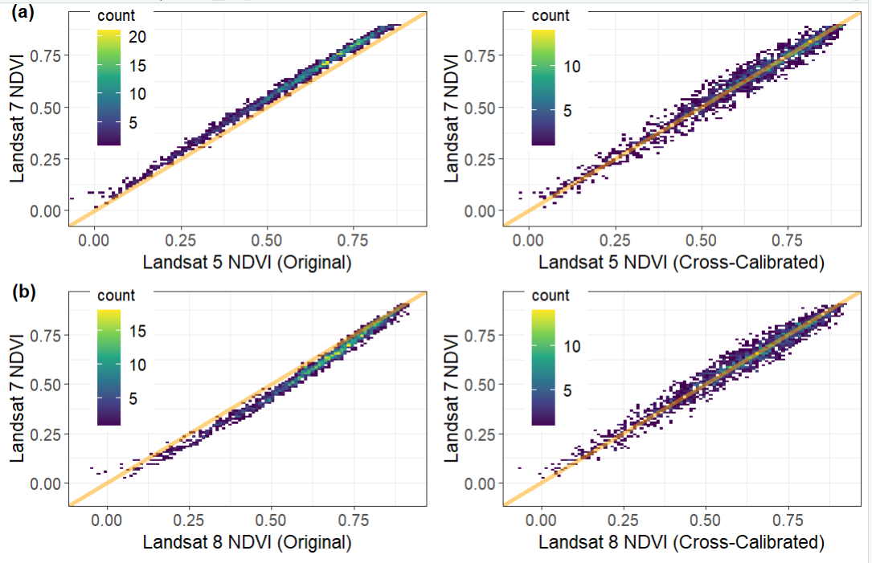

**Figure S3:** correlations between (a) Landsat 5 and 7, and (b) Landsat 7 and 8, pre and post cross-calibration using a random forest model. Orange lines depict perfect one-to-one correlations.

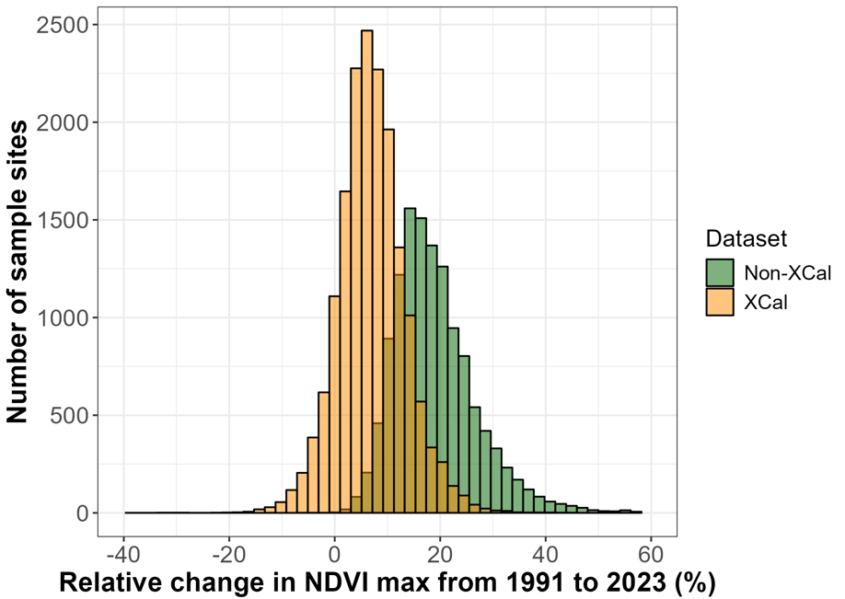 **Figure S4:** Histograms of relative NDVIMax change per pixel between 1991 and 2023—the first and last years of data collection. The orange histogram shows NDVI values with cross-calibration applied; the green histogram shows values without cross-calibration.

**Landsat Phenological spline fitting**

From the cross-calibrated data we quantified the growing season characteristics using *LandsatTS*. This process involved iteratively fitting cubic splines to pixel measurements pooled over a seven-year moving window within the growing season. Further details can be found in the supplementary materials (Figure S4). Observations were exponentially weighted by distance in number of years from the focal year, so that observations from the focal year were most important in calculating its spline; observations outside the focal year (but inside the focal window) are thus used to bolster the number of datapoints through which to fit the spline. Outliers were excluded and the splines refitted until all observations were within a 30% bound of the fitted spline. If there were fewer than ten observations in the focal window, the spline was not fitted. As a further precaution, we removed pixels whose splines didn’t reach a peak before the date of the final observation.

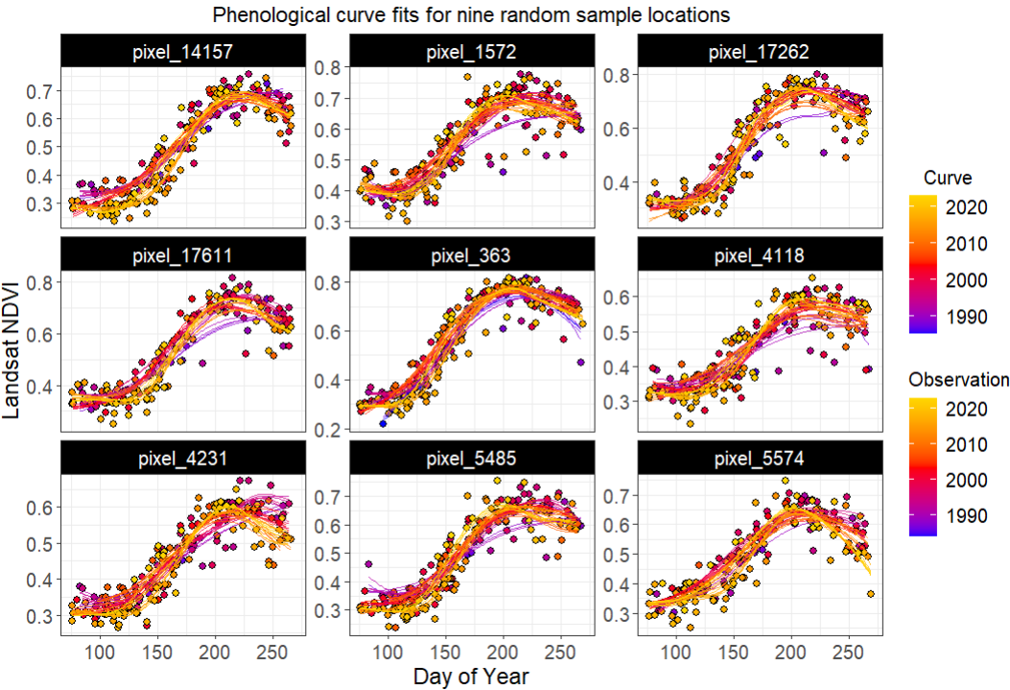**Figure S5:** Seasonal NDVI progression for each year from 1985 to 2023 for nine randomly selected pixels in the Isle of Rum study area. Points and their corresponding fitted phenological curves (cubic splines) are colour coded by year. Plot produced using *LandsatTS* package prior to removal of pixels from splines which didn’t reach a peak.

A significant relationship was found between the number of cloud-free observations in a given year and its estimated NDVIMaxDOY. We therefore decided to exclude this metric from our analysis. No such relationship existed for the vegetation index NDVIMax.

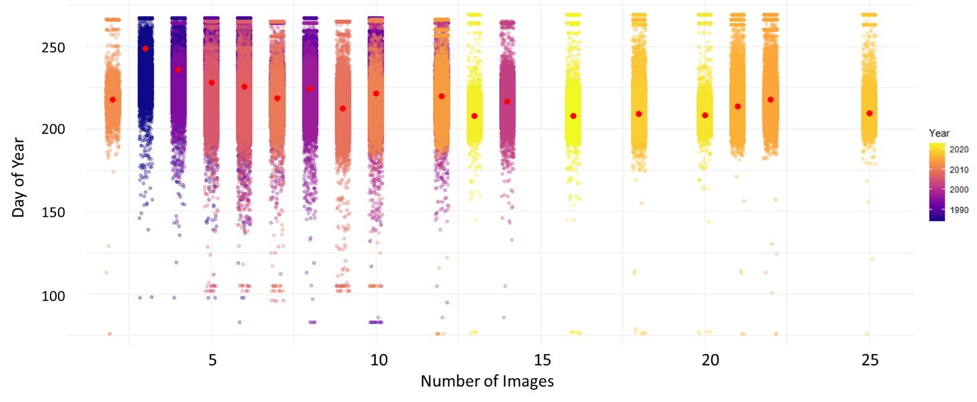

**Figure S6:** Annual NDVIMaxDoy model predictions compared against the number of images available for each year. Colour depicts year; red dots overlaid indicate the estimated NDVIMaxDoy for that year. A significant negative relationship was detected: the more images available, the lower the estimate of NDVIMaxDoy. This led to us discarding this metric.

**Vegetation Map with MODIS pixel centroids overlaid**

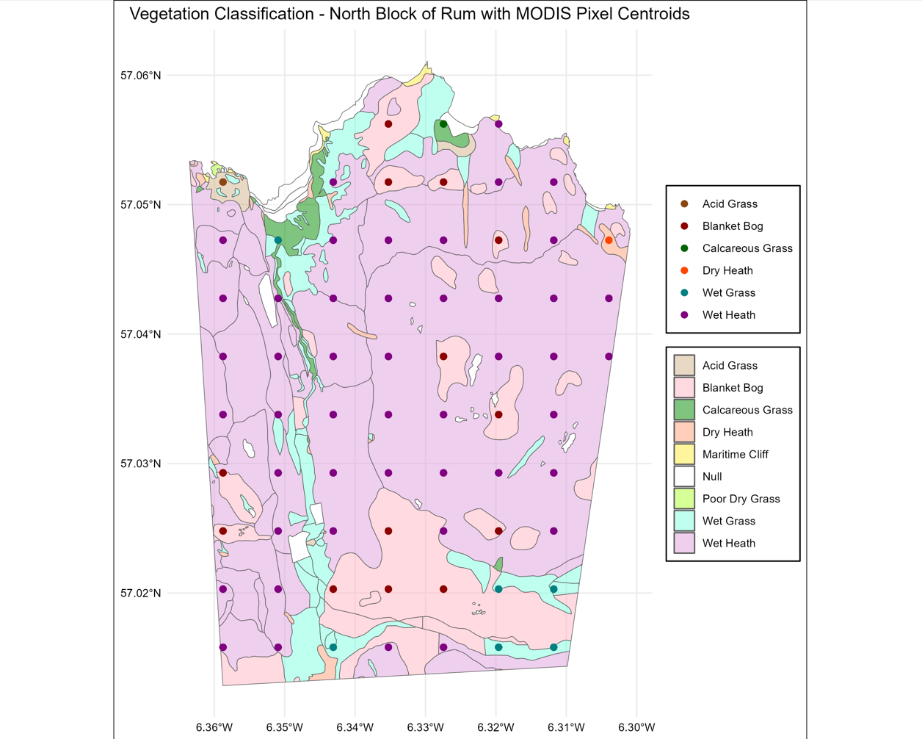

**Figure S7:** Map of the study area with MODIS pixel centroids overlaid. Pixels were assigned to a vegetation type based on which vegetation type on the Rum vegetation map the centroid of the pixel overlapped with.

**MODIS metrics**

Vegetation index metrics in the MODIS product include EVI Amplitude (EVIAmp), EVI Minimum (EVIMin) and EVI Area (EVIArea) (Figure S8); we used EVIAmp in our analyses as the best comparison to NDVIMax. Although a EVI Maximum metric could theoretically be calculated as the sum of EVIAmp and EVIMin, the MODIS product constrains EVIMin to a lower bound of 0.15, potentially introducing skew, so we stick with EVIAmp.

Annual ‘phenometrics’ are provided at six stages (Figure S8), calculated as the day of year on which a percentage threshold of the EVIAmp was first or last crossed: Greenup (first crossed 15% of the EVIAmp), MidGreenup (50%), Maturity (90%), Senescence (last crossed 90% EVIAmp), MidGreendown (50%) and Dormancy (15%). We used MidGreenup and MidGreendown as the most reliable triggers of phenology (Friedl et al., 2022). The day at which EVI reached its peak was missing from the data, so we used Maturity as a proxy for EVIMaxDOY.

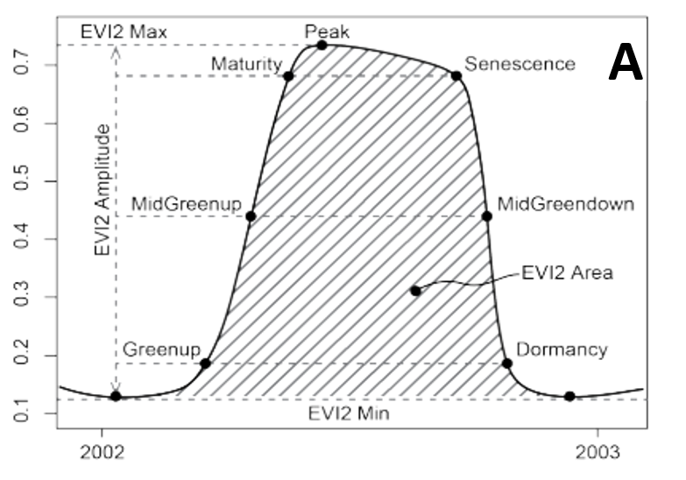

**Figure S8:** Diagram of the vegetation index and phenological metrics outputted by the MODIS MCD12Q2 product, taken from the product user guide (Friedl et al., 2022).

**Landsat Results**

Wet grassland exhibited a significantly stronger increase in NDVIMax over time compared to acid grassland, while blanket bog and wet heath showed significant negative interactions, indicating a slower increase in NDVIMax in these groups which are less preferred by the deer. Other interaction terms were not statistically significant. These results suggest that temporal trends in vegetation greenness are not uniform across vegetation types, with wet grassland in particular greening more rapidly than other groups (Figure S9). Note this is the same figure as Figure 6 in the main text, but zoomed in and with the 95% confidence intervals removed to allow the reader to see the difference in slopes between vegetation types.

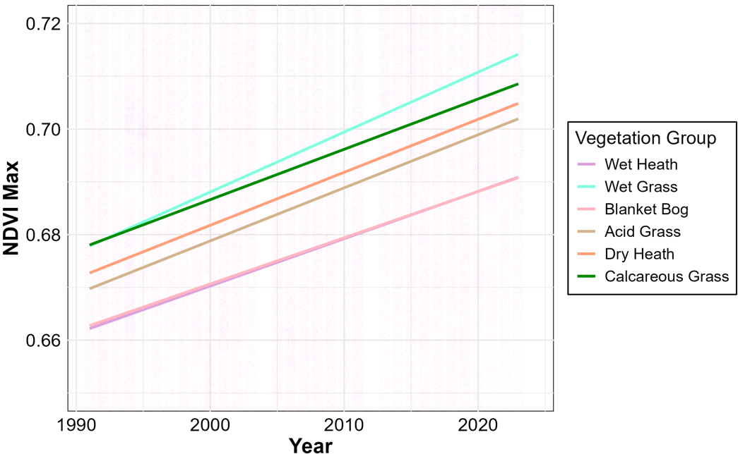 **Figure S9:** Model estimates of NDVI Maximum by vegetation type from Landsat data. Individual pixel estimates are coloured by vegetation type. Trendline predictions from the model with vegetation type and year interactions are overlaid.